**CSE1007- JAVA PROGRAMMING LAB  
DATE:18.09.2019**

1. Java Program to Replace First Letter of Every Word with Capital Letter.
2. Java Program to Reverse the Contents of a File and Print it.
3. Java Program to Update Details of Employee Using Files.
4. Java Program to Convert the Content of File to LowerCase.
5. Java Program to Create and Count Number of Characters in a File.
6. Java Program to Join Lines of Two given Files and Store them in a New file
7. Java Program to Collect Statistics of a Source File like Total Lines, Total no. of Blank Lines, Total no. of Lines Ending with Semicolon.

1. Soln:

import java.io.\*;

class One

{

public static void main(String[] args) throws IOException

{

FileReader fr = new FileReader("/home/matlab/file.txt");

String s="";

int i;

while((i = fr.read())!= -1)

s+=Character.toString((char)i);

System.out.println(s);

String[] arr = s.split(" ");

String fin = "";

for(String j:arr)

{

char c = j.charAt(0);

String sub = j.substring(1,j.length());

if(Character.isLowerCase(c))

c = Character.toUpperCase(c);

fin+= (c + sub + " ");

}

System.out.println(fin);

}

}

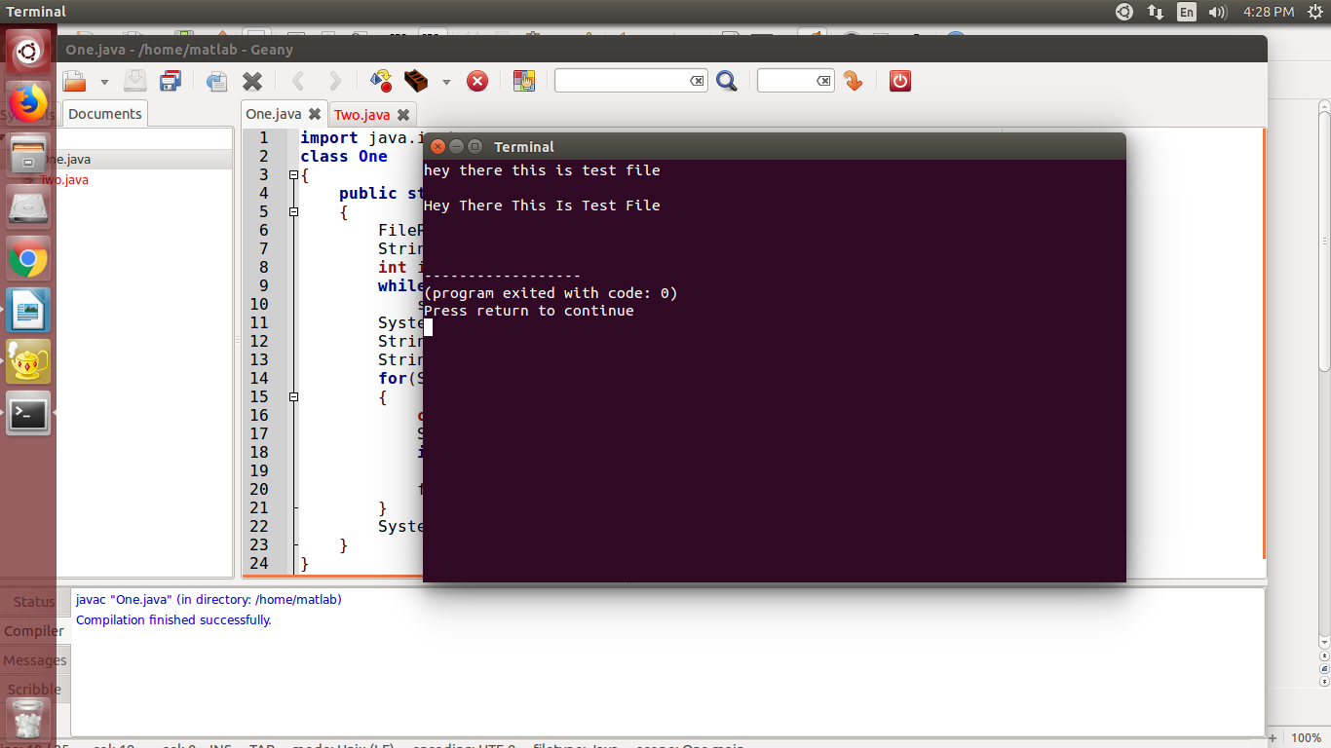

2. Soln:

import java.io.\*;

class Two

{

public static void main(String[] args) throws IOException

{

FileReader fr = new FileReader("/home/matlab/file.txt");

String s="";

int i;

while((i = fr.read())!= -1)

s+=Character.toString((char)i);

System.out.println(s);

for(int j=s.length()-1;j>=0;j--)

System.out.print(s.charAt(j));

}

}

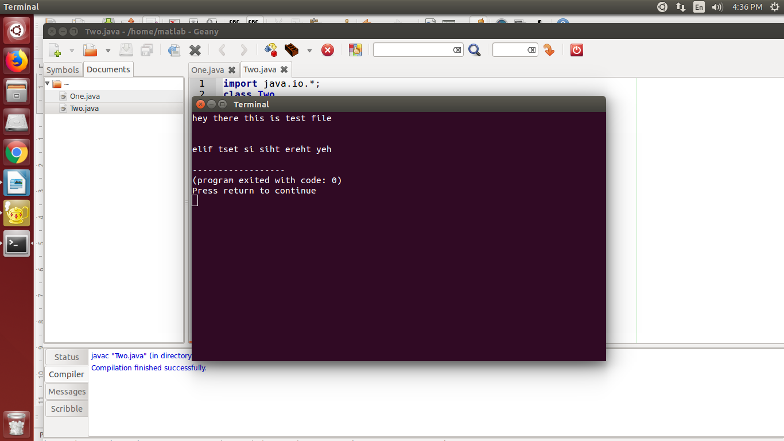

3. Soln

import java.io.\*;

import java.util.Scanner;

class Three

{

public static void main(String[] args) throws IOException

{

Scanner sc = new Scanner(System.in);

FileWriter fw = new FileWriter("/home/matlab/file.txt");

fw.write("Name: ABC\n");

fw.write("ID: 123456\n");

fw.write("Dept: XYZ\n");

fw.close();

FileReader fr = new FileReader("/home/matlab/file.txt");

String s="";

int i;

System.out.println("File after writing: \n");

while((i = fr.read())!= -1)

System.out.print((char)i);

}

}

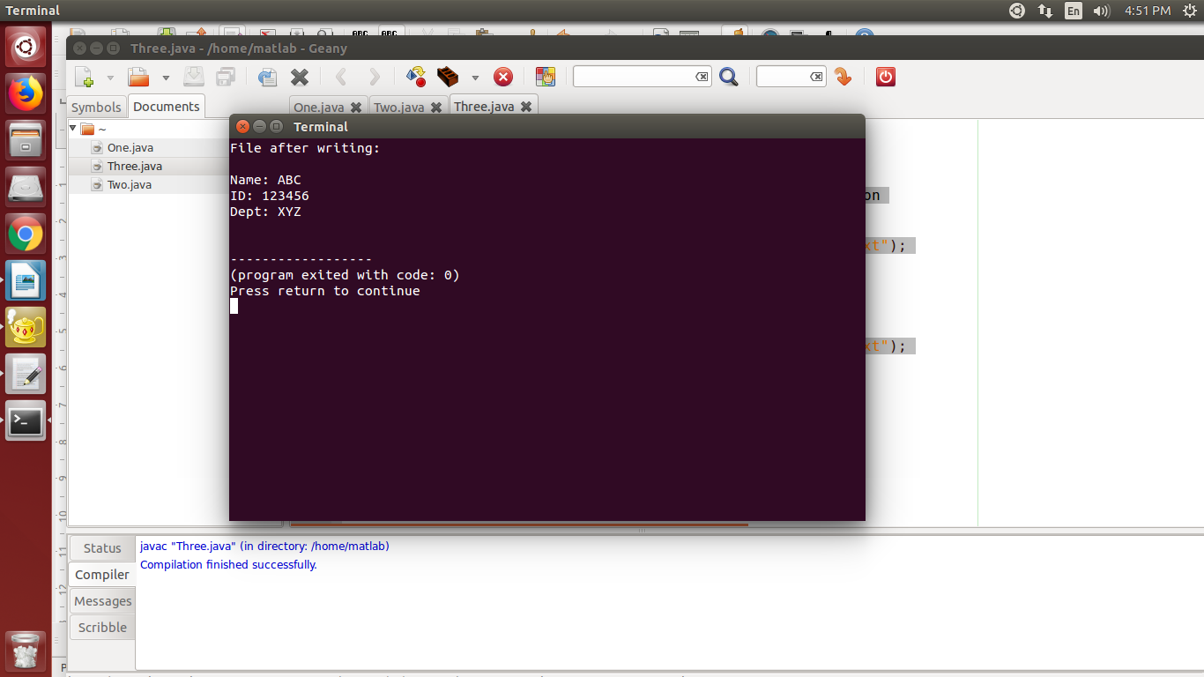

4.

Soln:

import java.io.\*;

class Four

{

public static void main(String[] args) throws IOException

{

FileReader fr = new FileReader("/home/matlab/file.txt");

String s="";

int i;

System.out.println("File content before writing:");

while((i = fr.read())!= -1)

s+=Character.toString((char)i);

System.out.println(s);

String fin = "";

for(int j=0;j<s.length();j++)

{

fin+=Character.toLowerCase(s.charAt(j));

}

FileWriter fw = new FileWriter("/home/matlab/file.txt");

fw.write(fin);

fw.close();

FileReader fr2 = new FileReader("/home/matlab/file.txt");

System.out.println("File content after writing: \n");

while((i = fr2.read())!= -1)

System.out.print((char)i);

}

}

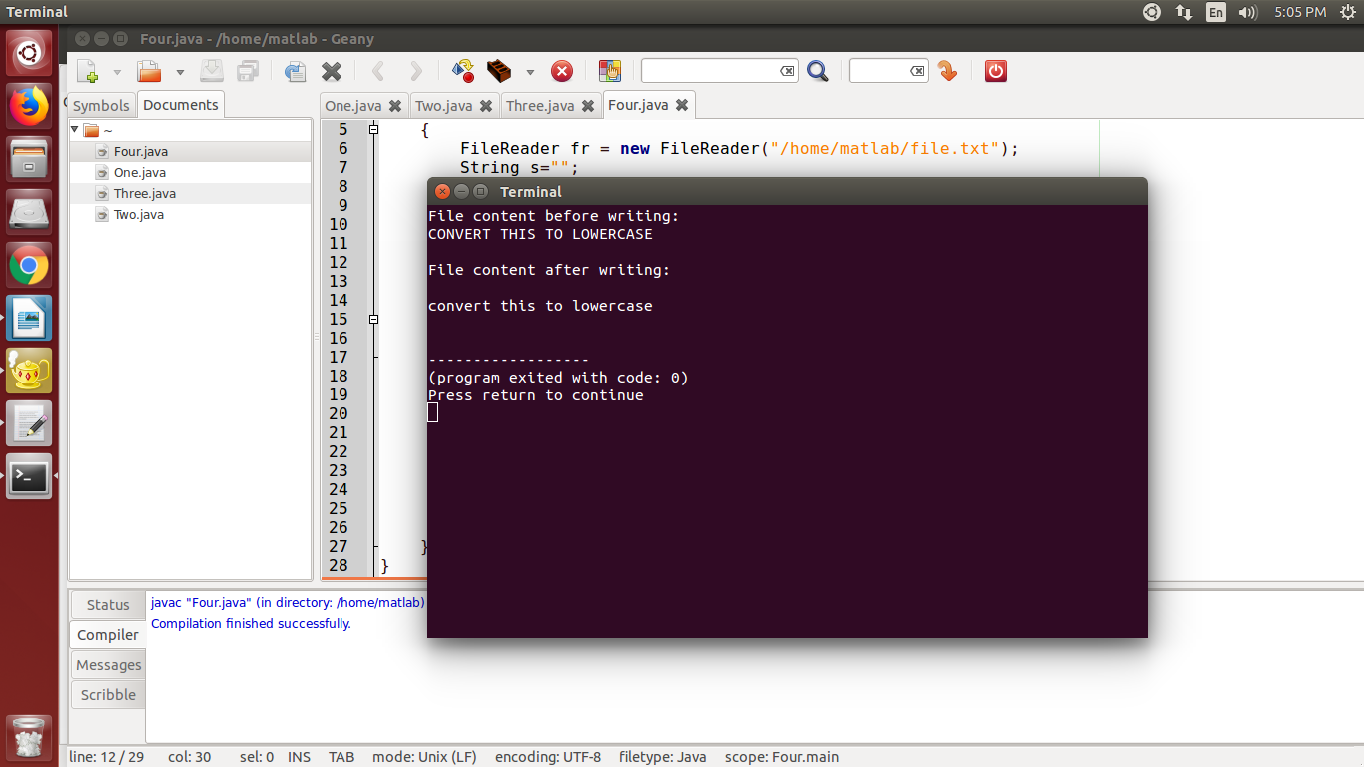

5. Soln:

import java.io.\*;

class Five

{

public static void main(String[] args) throws IOException

{

int i,count=0;

String writingString = "Hello World";

File f = new File("/home/matlab/NewFile.txt");

FileWriter fw = new FileWriter(f);

fw.write(writingString);

fw.close();

FileReader fr = new FileReader(f);

while((i = fr.read())!= -1)

count++;

System.out.println("Number of characters in new file: "+count);

}

}

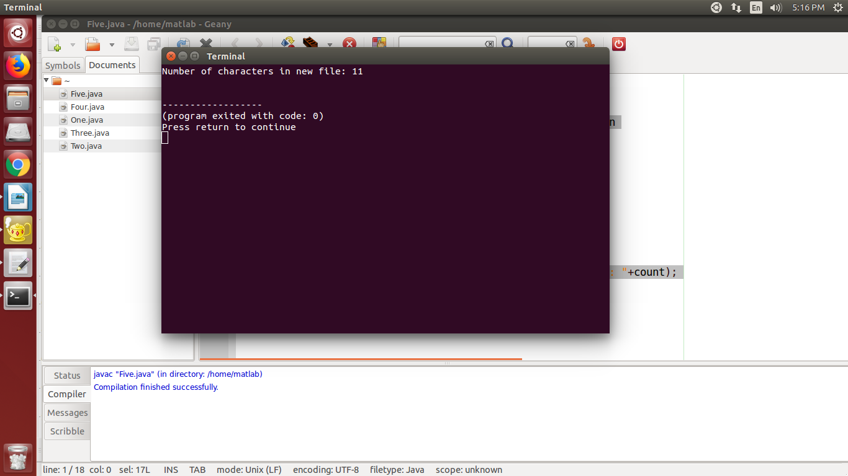

6.